C PROGRAMMING TO FIND THE GREATEST ELMENT AMONG THE ARRAY ELEMENT

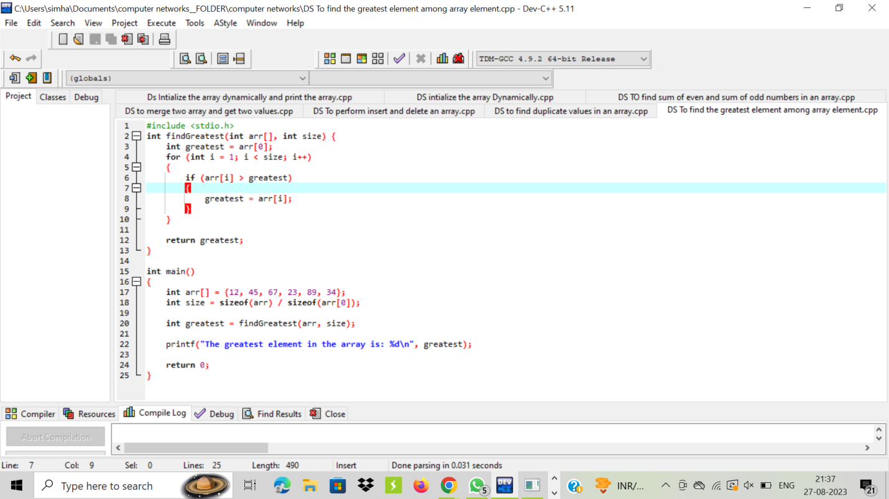

OUTPUT:

